**WIN’s 2022 End of Year Report**

**A message from the Chair – Christina Pourarien**

It has been an incredible honor to serve as your current WIN BRG Chair. Since July 2022, I continued to feel overjoyed by the amazing WIN members who have shared their desire and passion for improving our communities and creating a space where everyone feels they belong.

As another holiday season is approaching, I wanted to send a special message of thanks and gratitude for all of your support and hard work you have been doing and for all we have accomplished this last year.

**Wednesday, November 30, 2022 – Governor Inslee’s Equity Summit**

On Wednesday, November 30, 2022, WIN BRG leadership team and members attended the Governor Inslee’s Equity Summit. I was also incredibly honored that WIN had a booth during the Equity Summit last week as we had an opportunity to share information about our mission while handing out some WIN swags and candies from around the world.

There was a great turnout in person (photos included below) and virtually. I was amazed with the Office of Equity planning for this event as they only had two months to prepare. I would like to take this opportunity to share a big THANK YOU to our WIN volunteers that hosted the WIN BRG during this event:

* Lorraine Lee, WIN Executive Sponsor
* Philip Muirhead, WIN Special Project co-lead
* Atina Silivelio, WIN Advocacy co-lead
* Sally Elliott, WIN co-chair

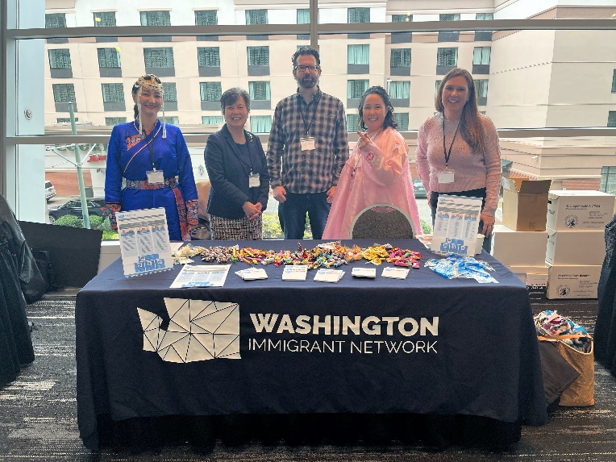

Photo: Washington Immigrant Network table.

Left to right – Nadia Damchii, DSHS, Lorraine Lee, OAH, Phillip Muirhead, OAH, Christina Pourarien, ESD, and Sally Elliott, L&I

This Equity Summit was just the start of a conversation for all of us to be ready, show up, and start the discussion in cultivating a culture of belonging that honor each and every one’s humanity with dignity and respect. The purpose of this event was to bring “community and state government together to lay down a strong foundation for achieving equity across Washington State government, now and for generations to come.” This event centered around our communities and partnered to advance the Pro-Equity and Anti-Racism.

In 2020, Governor Inslee signed into law a new Office of Equity. Washington is the first state to have an Office of Equity to provide an opportunity for all to flourish and appointed Dr. Karen Johnson to lead the office to work across agencies to address, remove, and challenge disparities.

[**Executive Order 22-02**](https://www.governor.wa.gov/sites/default/files/exe_order/22-02%20-%20Equity%20in%20State%20Government%20%28tmp%29.pdf): Achieving Equity in Washington State Government (link attached)

[**Executive Order 22-04**](https://www.governor.wa.gov/sites/default/files/exe_order/22-04%20-%20Implementing%20PEAR%20%28tmp%29.pdf): Implementing the Washington Pro-Equity and Anti-Racism (PEAR) Plan & Playbook (link attached)

I encourage you to watch the Equity Summit video from TVW if you were not able to attend this event in-person or virtual.

**TVW videos:**

[**2022 Governor's Equity Summit - TVW**](https://tvw.org/video/2022-governors-equity-summit-2022111220/) 8:00 am

[**2022 Governor's Equity Summit - TVW**](https://tvw.org/video/2022-governors-equity-summit-2022111221/?utm_medium=email&utm_source=govdelivery) 2:45 pm

**WIN SmartHealth Activity:**

WIN BRG also partnered with our amazing SmartHealth Promotion Consultant, Heidi Helsley in creating an activity where state and school employees can engage with our Career Development sub-committee and attend WIN’s workshops. I am thrilled to share with you that there were over **1,100** employees across Public Employees Benefits Board (PEBB) and School Employees Benefits Board (SEBB) program that joined our WIN activity!!!

This [SmartHealth](https://gcc02.safelinks.protection.outlook.com/?url=https%3A%2F%2Fsmarthealth.hca.wa.gov%2FHome&data=05%7C01%7Cchristina.pourarien%40esd.wa.gov%7Cfa81a733e443444002d208da7bddf8ed%7C11d0e217264e400a8ba057dcc127d72d%7C0%7C0%7C637958490680207036%7CUnknown%7CTWFpbGZsb3d8eyJWIjoiMC4wLjAwMDAiLCJQIjoiV2luMzIiLCJBTiI6Ik1haWwiLCJXVCI6Mn0%3D%7C3000%7C%7C%7C&sdata=giNa9cR3xxCsqjvrRoLp7Ypjbbu6e%2B4eOlHfYltlaJo%3D&reserved=0) activity is available through December 31, 2022.

**WIN’s 2021-2022 Annual Report - Highlights includes:**

* Letter from Chair – Joanne Lee
* [You Belong video](https://youtu.be/kmi-MPtfJBg)
* Allyship: You and I Together
* June 2022 Annual Celebration

[Click to see WIN’s 2021-2022 Annual Report](https://static1.squarespace.com/static/5b69c2a0c258b4bd8fe7b314/t/62f5573e3e8a6b7f3a51200f/1660245825675/WIN+Annual+Report+2021-2022.pdf)

In closing, I want to thank each of you. Thank you for being a wonderful collaborator, supporter, and friend. I am so proud to be a member of WIN BRG and honored to have been trusted by you to lead WIN’s mission and purpose in expanding opportunities for immigrants who are current and future employees within the Washington state government as well as serving as a resource for all immigrants who are state employees to connect, celebrate our diverse lived stories, and our given names. Together we can shape a better work environment driven by courage, dignity, and kindness if we are vulnerable to lean into building it with each other in creating a culture where we all belong.

To all of you and your families, I wish you a prosperous, happy, and healthy 2023!

새해 복 많이 받으세요

Wishing you a Happy 2023,

Christina Pourarien