ANNUAL REPORT
2019-2020

September 1, 2020

Executive Summary _____________________ _

The Washington Immigrant Network (WIN began its second year on August 5, 2019. WIN is a Business Resource Group (BRG) for Washington State’s employees, the fourth such BRG, with a mission to:

Expand opportunities for immigrants who are current and future employees within Washington state government. Serve as a resource for all immigrants who are state employees to connect, share, and educate each other and Washington state agencies on the skills, expertise and cultural value of a diverse workforce.

WIN’s general goals are to:

- Retain and support immigrant state employees by providing a support structure, education, career progression and leadership development assistance.
- Recruit immigrants to state service through outreach and educational activities.
- Serve as a resource for Office of Financial Management (OFM) State Human Resources and state agencies in creating and sustaining a diverse and inclusive workforce
Immigrant here is defined as a person born in a foreign country or a person who has a foreign-born parent.

WIN also elected five officers for the 2019-2020 year, with Christine Stalie serving as immediate past-chair, Nam Nguyen serving chair, Kim Sauer serving as secretary, Alex Countouriotis serving as Communications Officer, and Jarrod Irvin serving as Secretary. Due to changes in work assignments and other responsibilities, Alex and Jarrod stepped down as officers. Joanne Lee took over handling communications for WIN.

WIN held monthly meetings from August 2019 to July 2020. The theme for the year was My Immigrant Journey. In meetings, WIN members shared their, and their family, journey to the United States and life as an immigrant. Additionally, WIN provided professional development training. Up until March 2020, WIN held in-person meetings. An average of 25 members attended each in-person meeting.

Starting in April 2020, WIN met online due to the Covid-19 pandemic. Although the pandemic hampered aspects of WIN’s operation, including the cancellation of the annual June event, online meetings provided the opportunity to increase participation. An average of 40 members for online meetings.

WIN plans on continuing to fulfill its charter goals in 2020-21.
History____________________________ _____

WIN started as an initiative by Lorraine Lee, Chief Administrative Law Judge of the Office of Administrative Hearings (OAH), which serves as the sponsoring agency. Judge Lee convened meetings to organize WIN in early 2017, inviting state workers interested in forming a BRG for immigrant state workers. These meetings resulted in a charter and by-laws.

WIN officially began its second year on August 5, 2019. For the year, Nam Nguyen served as chair, Kim Sauer served as co-chair, and Christine Stalie served as immediate past chair. At the beginning of the year, Alex Countouriotis served as Communications Officer and Jarrod Irvin serving as Secretary, respective. Both had to resign due to change in a change work assignment and other issues unrelated to WIN. Joanne Lee took over the communications duties.

WIN held monthly meetings from August 2019 to July 2020. From August to March 2020, WIN held monthly in-person, with most meetings held at the Liquor and Cannabis Board building, with options for members to attend online. Due to the Covid-19 pandemic, WIN moved its meeting to online only through Zoom from April 2020 to July 2020.

Starting in January 2020, WIN started to plan for second anniversary event, scheduled for June 2020. WIN had booked the facility and speaker for the event, as well as obtained sponsorship from the Department of Licensing, the Liquor and Cannabis Board, and the Lottery Commission. Unfortunately, due to the Covid-19 pandemic, WIN cancelled the event.

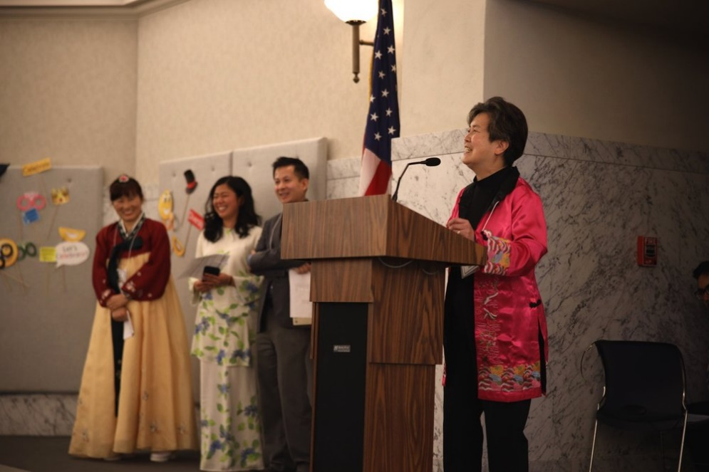

Committee and Membership____________ ___

WIN has an email circulation list with over 100 contacts who have participated in WIN meetings this year. Of this, approximately 25 to 30 regularly attend meetings either in-person or online between August 2019 to March 2020. Attendance increased to 35 to 40 when WIN moved to online only in April 2020. Those who regularly attend meetings are assigned to a committee. Below are committee accomplishments for 2019-20.

Professional Development Committee: Joanne Lee started the year as the chair of the professional development committee. The committee organized career development training for WIN members. The committee also implements the mentoring program

Recruitment Committee: Anupama Rao chairs the recruit/retention committee. The committee led the development of a poster to promote WIN. The committee also organized for WIN to have an information table at various career fairs and other events.

Event Planning Committee: Co-chair Kim led the committee to plan WIN’s second anniversary celebration, slated for June 2020. The committee organized speakers, performers and logistics for the event. WIN obtained sponsorship for the event from the Department of Licensing, the Liquor and Cannabis Board, and the Lottery Commission. Unfortunately, due to the Covid-19 pandemic, WIN had to cancel the event.

For the 2018-19 year, WIN had a communications committee which WIN consolidated in the communications officer position.

Monthly Meetings______ __________________

In 2019-20, WIN held nine meetings from August 2019 to July 2020. WIN did not have a meeting in December. From July 2019 to March 2020, WIN held most in-person meetings (with online attendance option) mostly at the Liquor and Cannabis Board (LCB) Building at 1025 Union Ave SE, Olympia, WA 98501. Due to the Covid-19 pandemic, WIN met online from April 2020 to July 2020. Meetings were an hour and a half long at noon on the first Monday of the month. Below are highlights from the meetings:

August 2019: WIN kicked of its second year by introducing “My Immigrant Story,” a program where WIN members and guest speakers share theirs or theirs families’ immigrant experience. Chair Nam shared his family experience during the Vietnam War, and its connection to his family’s immigrating to America.

September 2019: Norene Pen, from the Department of Transportation, presented on the importance of being assertive.

October 2019: Lisa McClean presented on Washington State’s Census 2020 effort. Marissa VanHoozer, DES’s Chief Strategy & Performance Officer, told the story of her family’s immigrant journey from the Philippines.

November 2019: Elizabeth Fontanilla, DES’s Learning Design and Delivery Professional, presented on unconscious biases in the workplace.

January 2020: Jarrod Irvin, Diversity Consultant within the Department of Corrections’ Civil Rights Investigation Unit, presented on how to be an ally to the immigrant community.

February 2020: Cindy Guertin-Anderson, Director of the Washington State Employee Assistance Program (EAP), discussed the mental health services EAP provide for Washington State employees.

March 2020: Khurshida Begum, a community member, presented on her family experience as victims of human trafficking. Khurshida also catered the meeting with traditional Bengali food.

April 2020: At WIN’s first virtual meeting on Zoom, Joanne Lee presented on how to cope with physical distance during the pandemic.

May 2020: Mustafa Mohamedali, for the Department of Transportation, presented on his immigrant journey as a Muslim immigrant from Kenya.

June 2020: State Representative Cindy Ryu presented on her immigrant experience and the importance of civic engagement.

July 2020: Dr. Johnson, Equity Inclusion Administrator at the Department of Corrections, and Megan Matthews and Phil White, from BUILD, led a discussion on anti-racism.
The COVID Year____ __________________

WIN planned on celebrating its second anniversary on June 6, 2020 at the Lacey Community Center. Approximately 100 people attended the first anniversary event, including members of the communities, and over 40 State agencies participated, and WIN expected similar attendance. Representative Cindy Ryu was to give the keynote speech. However, due to the Covid-19 pandemic, WIN was forced to cancel the event. In lieu, WIN continue holding monthly meetings online, with Representative Ryu presenting in June.

WIN would like to thanks the following agencies and their directors for sponsoring the second anniversary event. Each agency agreed to allow WIN to hold the sponsorship fund for future events.

- The Liquor and Cannabis Board and its Director Rick Garza

- The Department of Licensing and its Director Teresa Berntsen

- The Lottery Commission and its Director Marcus Glasper

Budget 2018-2019_____ ___________________

As a BRG, WIN does not have an official budget. WIN instead relied on in-kind contributions provided by community organizations, individual members and various State agencies, including:

- The Liquor and Cannabis Board hosted WIN meetings at its main conference room.
- Khurshida Begum provided catering and spoke on human trafficking, for which she normally charge $500.
- Interagency Committee of State Employed Women (ICSEW) paid approximately $157.39 to host WIN’s website.
- Results Washington provided WIN with Zoom access for online meetings.

This does not include the hours expended by State employees to work on WIN. Most of these hours were volunteered, and outside of the employees’ official job description. We estimated that approximately 1000 hours of work was expended to run WIN from August 2019 – July 2020.

Goals for 2020-2021___ __________________

WIN will continue to work on the goals written in the charter. The incoming officers will also set goals for 2020-21. Some possible goals are:

- Provide workshops and resources to help enhance career development and advancement;

- Connect and strengthen networking relationships within memberships through story sharing and mentorship;

- Outreach and build membership;

- Partner and collaborate with other BRGs in promoting diversity, equity, and inclusion in the Washington state government.

APPENDIX A

APPENDIX B

