Meeting Location: Liquor and Cannabis Board
Conference Room 108 and 109
1025 Union Avenue SE
Olympia, WA 98504

Meeting time: January 6, 2020
12-1:30 pm.

Time | Agenda | Facilitator | Meeting Note/Action Items
12:00 | Welcome  Icebreaker | Nam  Kim
12:10 | Agency Spotlight: DES | Joanne Lee  Michaela Doelman
12:20 | My Immigrant Journey: The Ally | Jarrod Irvin
1:45 | Subcommittees Discussion  Recruitment  Retention/Career Development  Event Planning | All | discuss DEI summit on January 21st and January 22nd.
1:15 | Subcommittees Report Out | All
1:25 | Push to Recruit New Members | Nam
1:30 | Adjourn | Nam

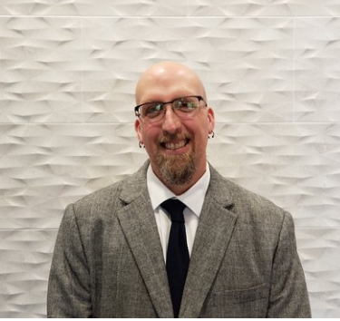
Speaker’s Biography: Jarrod Irvin works for the Department of Corrections (DOC) as a Diversity Consultant within the Department’s Civil Rights Investigation Unit. His educational background includes a Master of Science degree from Walden University in Social Psychology in which he focused on issues of bias, prejudice, and sexual violence. Jarrod has worked for the State of Washington since September 2017, when he transitioned from the U.S. Army where he worked on Joint Base Lewis-McChord as a program manager for the Army’s Equal Opportunity and Sexual Harassment and Assault Response & Prevention programs. Since joining DOC, Jarrod has helped to redesign the agency’s Civil Rights investigation process; improve policies regarding equity, diversity, inclusion, and respect; and develop curriculum for the Department’s first sexual harassment prevention training specifically for supervisors and managers. When he isn’t working, Jarrod enjoys baking, camping, and all things Halloween.

